1. Write a program that can divide six non-zero integers (two integers per division) from the user and display the result to the user. Create a function that will perform the division operation. Display only the non-decimal part of the quotient.

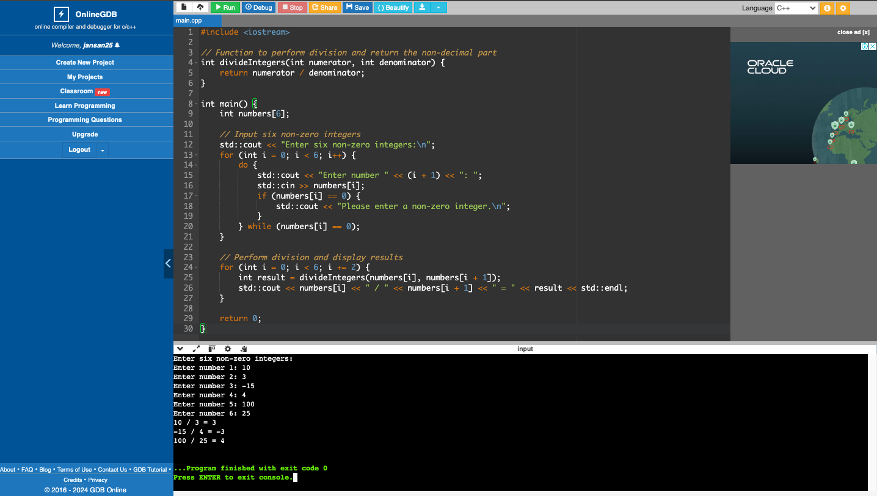

1. Write a program that will accept a short value from 10 to 99 and display them per digit (separated by a space).

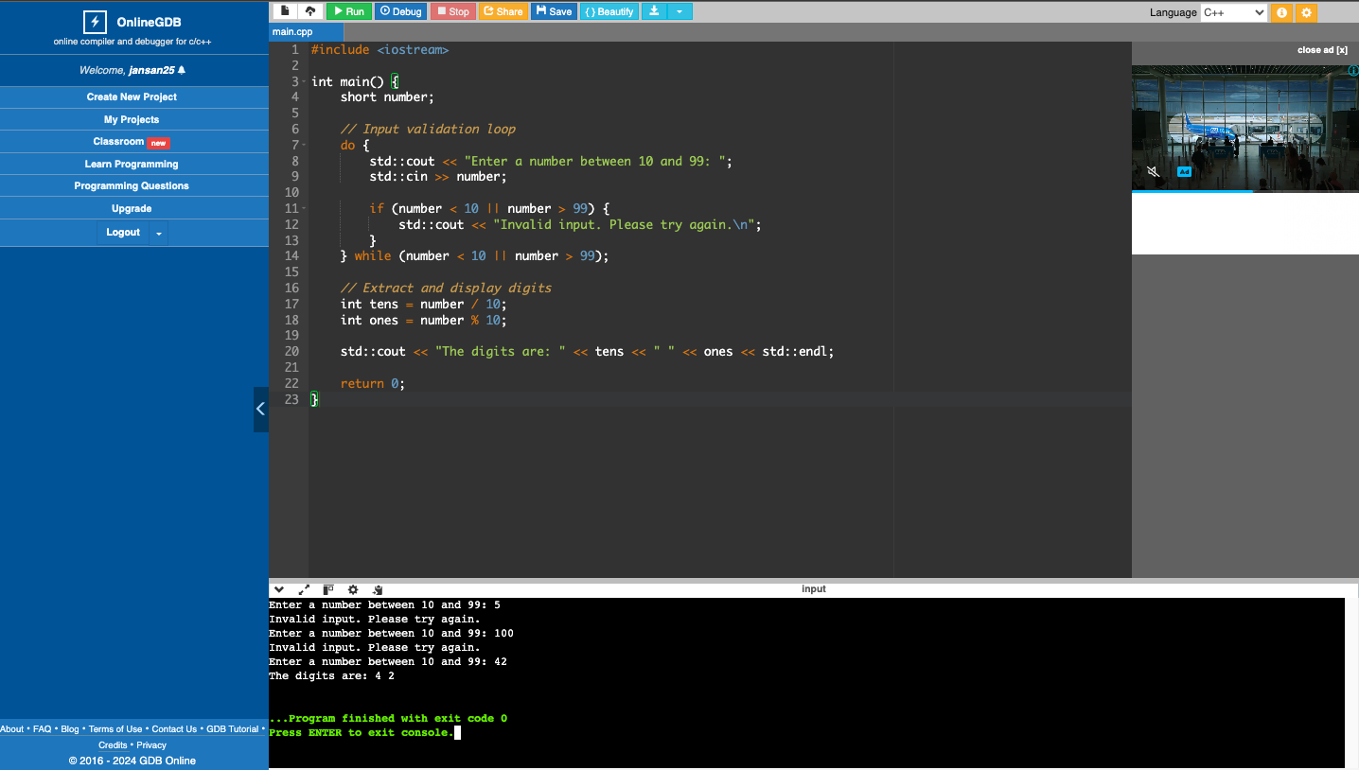

1. Write a program that will display the nth Fibonacci number. Create a function that will generate the nth Fibonacci number. Fibonacci numbers are numbers from the Fibonacci sequence which follows the pattern of 1, 1, 2, 3, 5, 8, 13, 21, 33, 54…

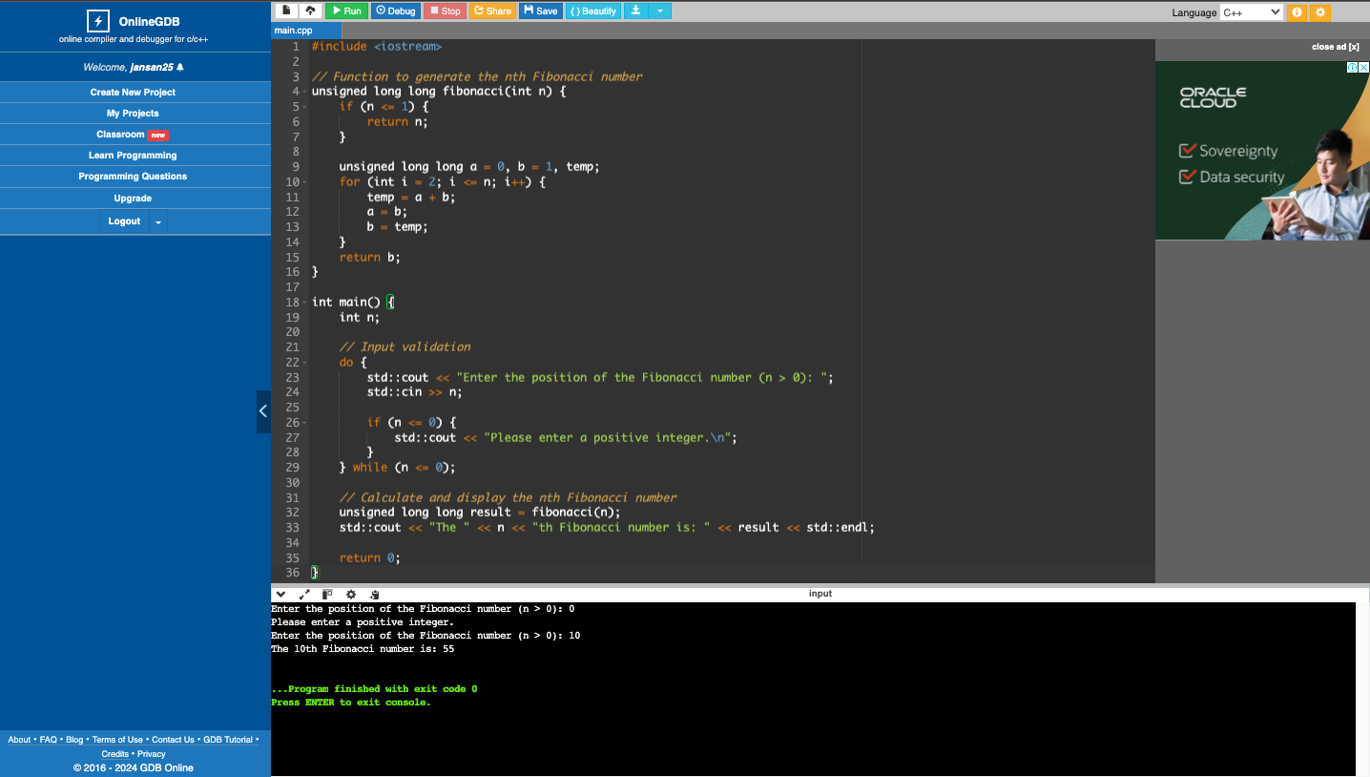

1. What can you conclude from this activity?

These activities demonstrate proficiency in creating functions, handling user input, performing arithmetic operations, manipulating strings, and implementing mathematical sequences in programming.